Problem 1:
Consider the following Python function:
def find_max(numbers):
return max(numbers)
Task:
• Write documentation for the function in all three formats:
(a) Docstring
(b) Inline comments
(c) Google-style documentation
• Critically compare the three approaches. Discuss the
advantages, disadvantages, and suitable use cases of each
style.
• Recommend which documentation style is most effective
for a mathematical utilities library and justify your
answer.
PROMPT: Generate documentation for the find_max(numbers) Python function using three formats: (a) Docstring, (b) Inline comments, and (c) Google-style documentation. Compare their advantages, disadvantages, and suitable use cases. Finally, recommend the most effective style for a mathematical utilities library and justify your choice.
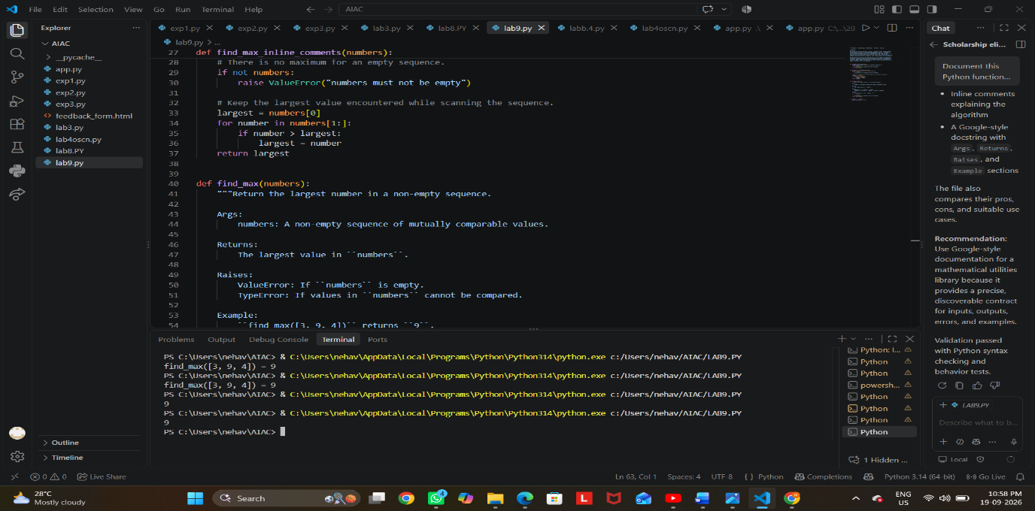
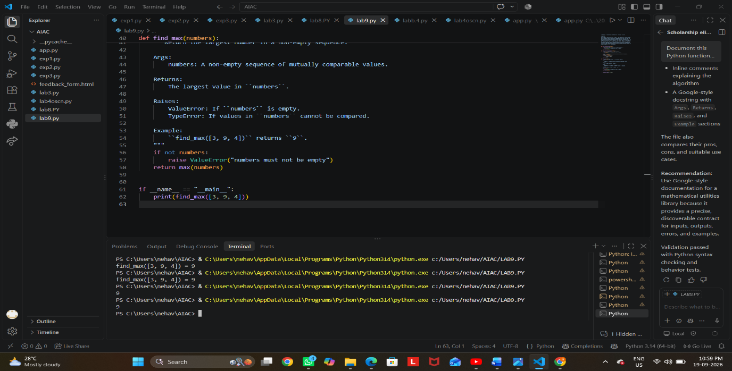

Problem 2: Consider the following Python function:
def login(user, password, credentials):
return credentials.get(user) == password
Task:
1. Write documentation in all three formats.
2. Critically compare the approaches.
3. Recommend which style would be most helpful for new
developers onboarding a project, and justify your choice.
PROMPT: Generate documentation for the given login(user, password, credentials) Python function using Docstring, Inline Comments, and Google-style documentation. Compare the three styles by their advantages, disadvantages, readability, and use cases. Finally, recommend the best style for new developers onboarding a project and briefly justify your choice.
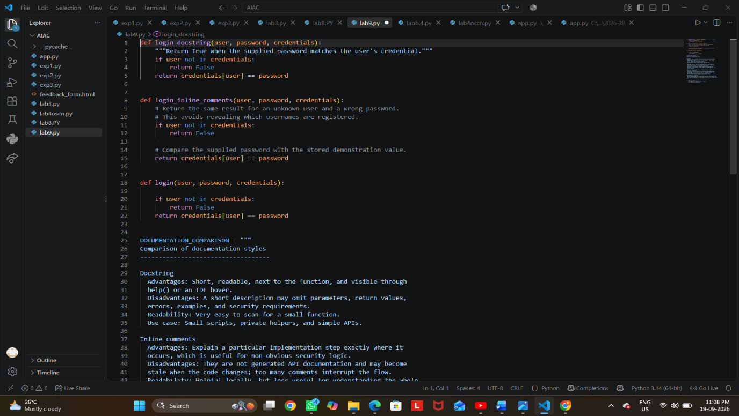
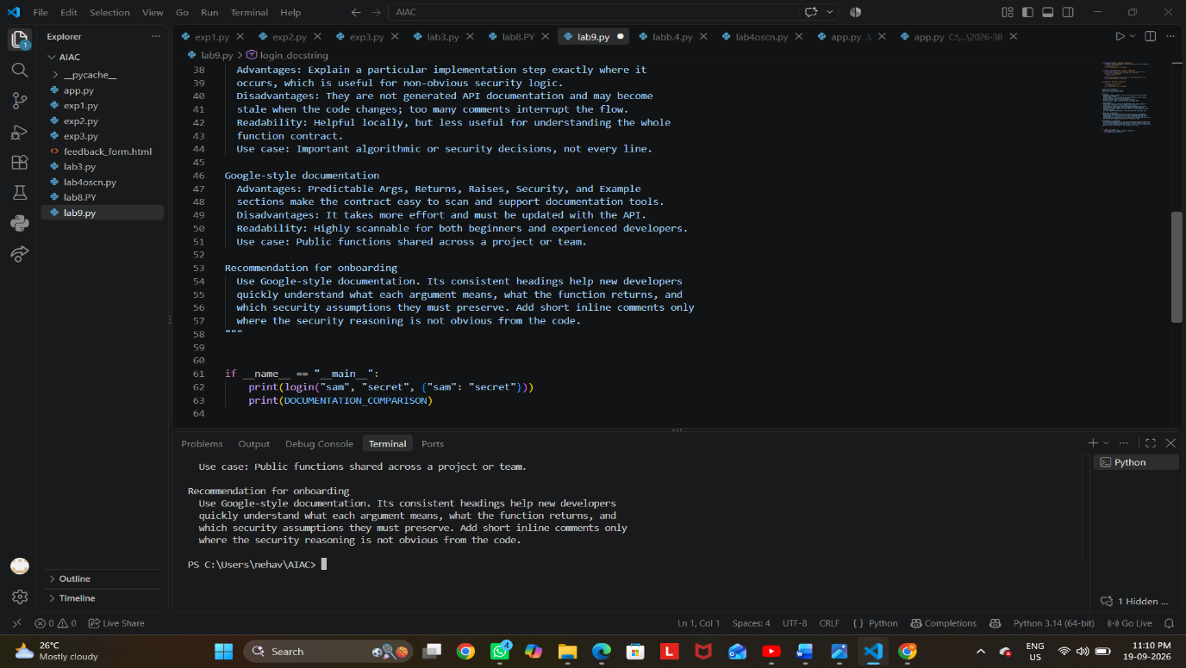
Problem 3: Calculator (Automatic Documentation Generation)
Task: Design a Python module named calculator.py and
demonstrate automatic documentation generation.
Instructions:
1. Create a Python module calculator.py that includes the
following functions, each written with appropriate docstrings:
o add(a, b) – returns the sum of two numbers
o subtract(a, b) – returns the difference of two numbers
o multiply(a, b) – returns the product of two numbers
o divide(a, b) – returns the quotient of two numbers
2. Display the module documentation in the terminal using
Python’s documentation tools.
3. Generate and export the module documentation in HTML
format using the pydoc utility, and open the generated HTML
file in a web browser to verify the output.
PROMPT: Generate a Python module named calculator.py containing four functions: add(a, b), subtract(a, b), multiply(a, b), and divide(a, b). Add clear docstrings to each function. Show how to display the module documentation in the terminal using Python’s pydoc tool, generate the documentation as an HTML file using pydoc, and open the HTML file in a web browser to verify it. Include the complete code and required terminal commands.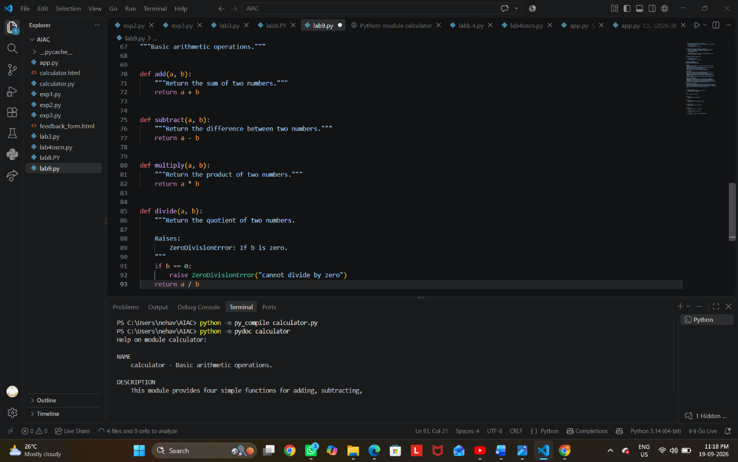

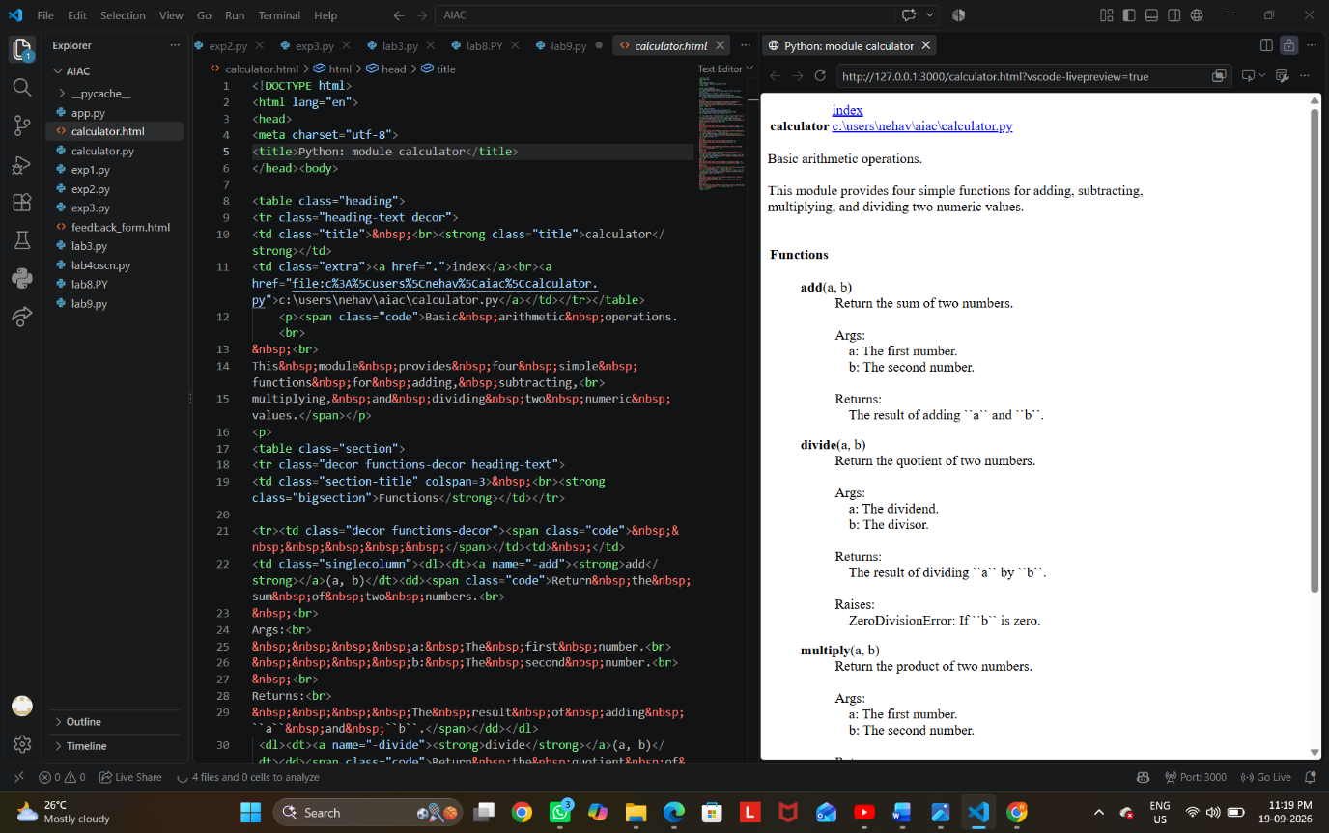
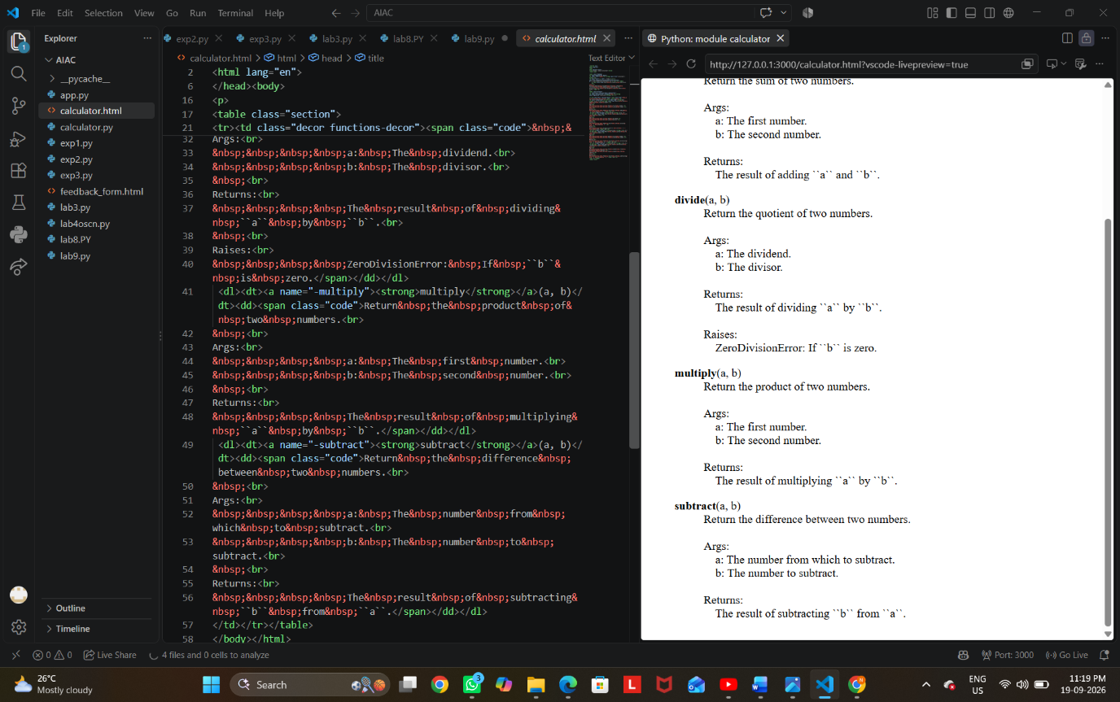

Problem 4: Conversion Utilities Module
Task:
1. Write a module named conversion.py with functions:
o decimal_to_binary(n)
o binary_to_decimal(b)
o decimal_to_hexadecimal(n)
2. Use Copilot for auto-generating docstrings.
3. Generate documentation in the terminal.
4. Export the documentation in HTML format and open it in a
browser.
PROMPT: Generate a Python module named conversion.py with these functions: decimal_to_binary(n), binary_to_decimal(b), and decimal_to_hexadecimal(n). Use Copilot to generate clear docstrings for each function. Then show the commands to display the module documentation in the terminal using pydoc, generate the documentation as an HTML file, and open the generated HTML file in a browser. Include the complete code and required terminal commands.

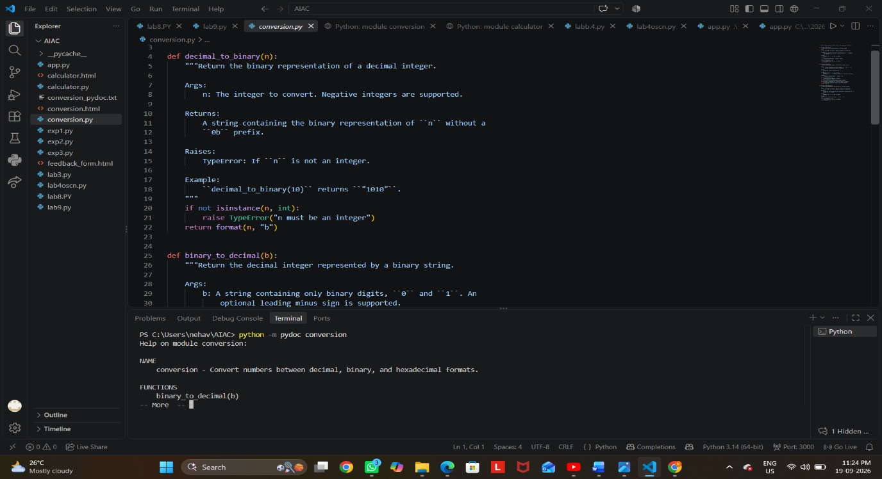
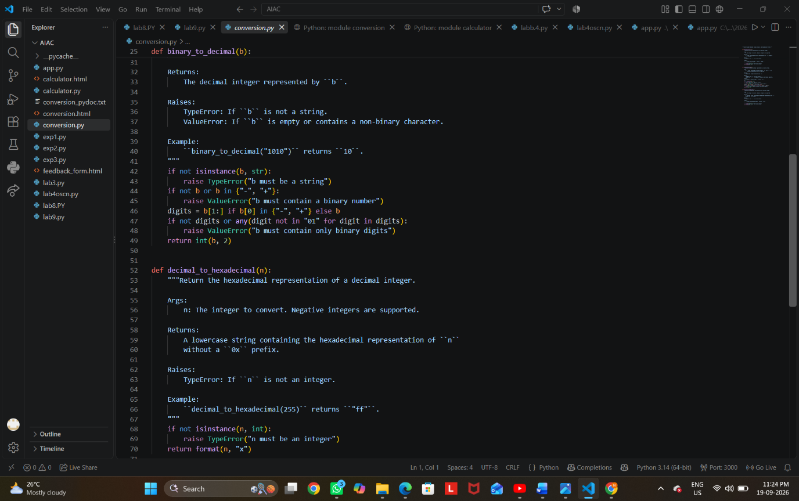
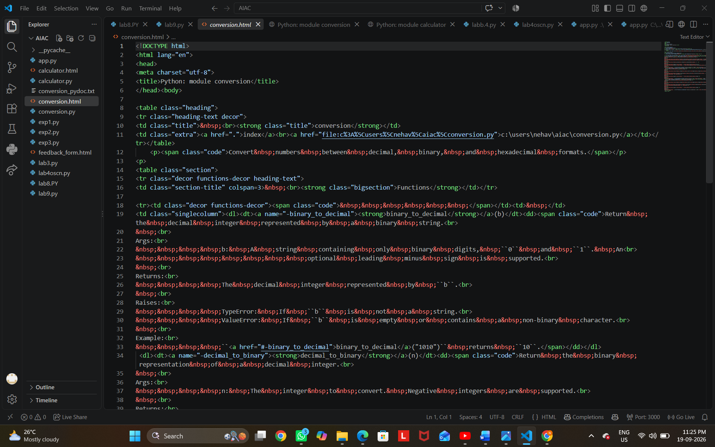

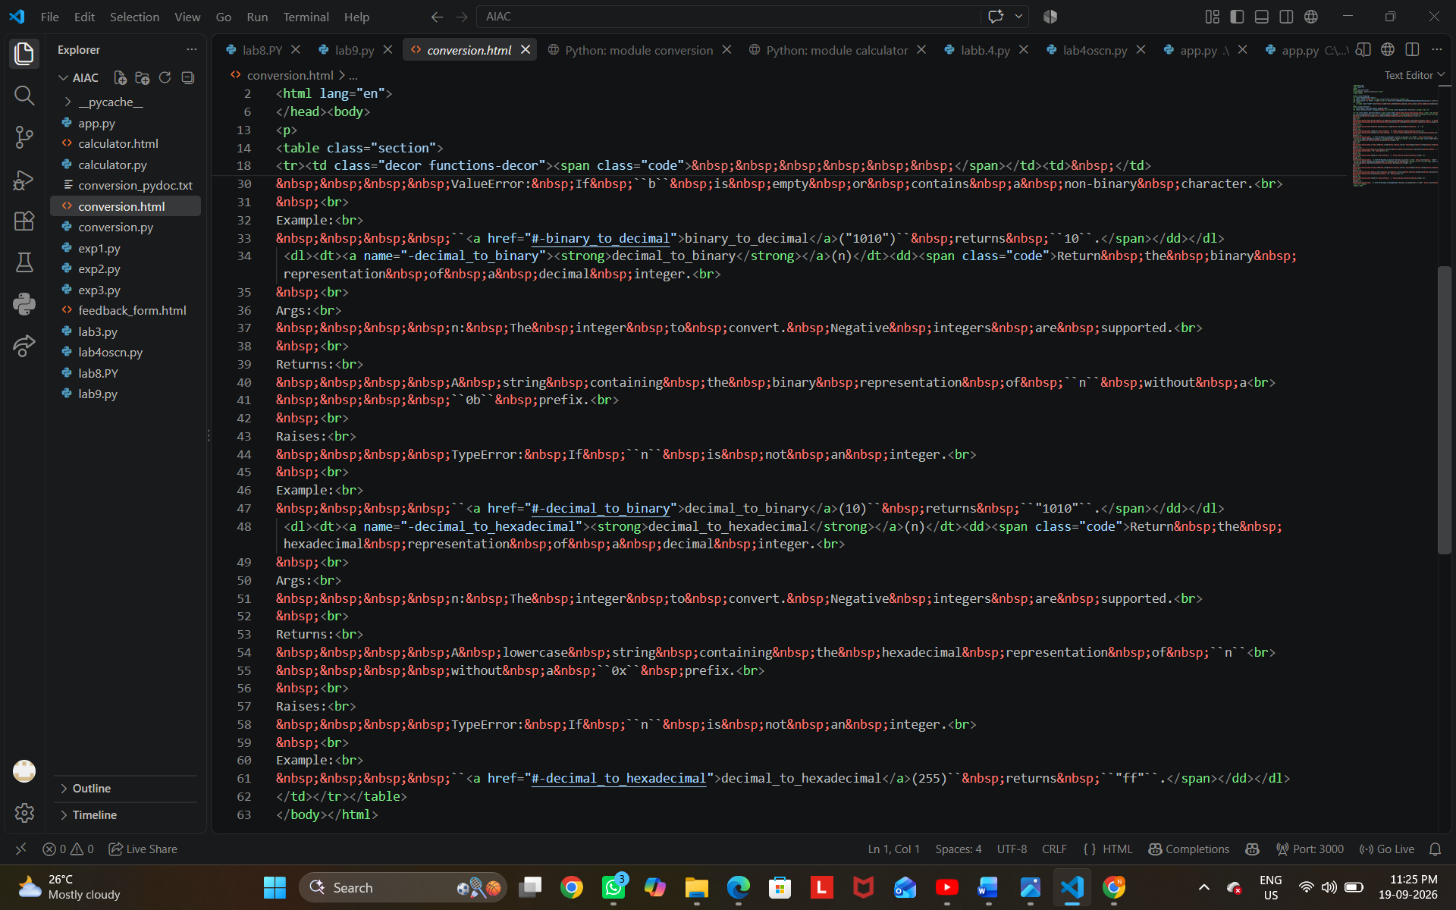
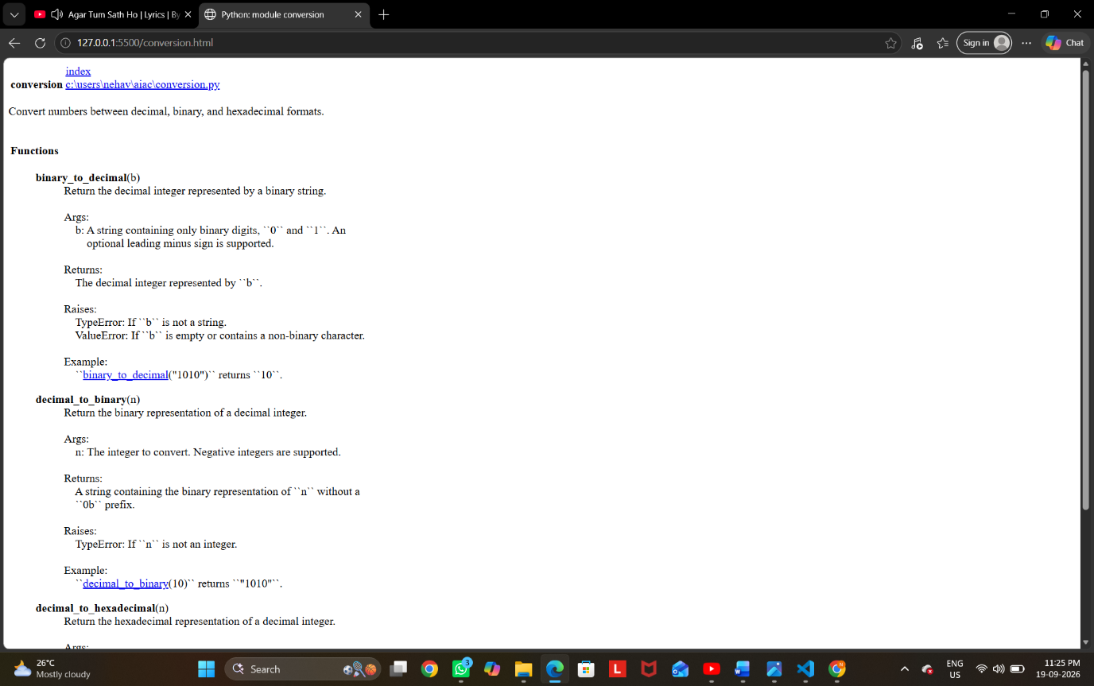
Problem 5 – Course Management Module
Task:
1. Create a module course.py with functions:
o add_course(course_id, name, credits)
o remove_course(course_id)
o get_course(course_id)
2. Add docstrings with Copilot.
3. Generate documentation in the terminal.
4. Export the documentation in HTML format and open it in a
browser.
PROMPT:Create a Python module named course.py with functions add_course(course_id, name, credits), remove_course(course_id), and get_course(course_id). Use a dictionary to store courses. Add clear Google-style docstrings to all functions. Then provide PowerShell commands to display the documentation using python -m pydoc course, generate HTML documentation using python -m pydoc -w course, and open course.html in a browser.

